 | MANDATORY REPORTING POLICY
Policy reveiwed by:  Kathie Arnold and Jamie Sharp |  | Ratified at school council:  To be reviewed:  September 2021
RATIONALE:
All children have a right to feel safe and to be safe. As teachers, we have a legal and moral responsibility to respond to serious incidences involving abuse and neglect of the children with whom we have contact, and to report instances that we believe involve physical abuse, sexual abuse or neglect.

AIM:
To ensure that childrens’ rights to be safe are maintained and each child is protected against physical and sexual abuse, and neglect.

IMPLEMENTATION:
- Any person who is registered as a teacher under the Education and Training Reform Act (2006), or any person who has been granted to teach under the Act, including Principals, is mandated to make a report to the Department of Health and Human Services (DHS) Child Protection. All concerns must be reported immediately to the Principal, or Assistant Principal.
(Teachers and Principals are mandated by law under section 184 of the Children Youth and
Families Act 2005 (CYFA) to make a report to child protection).

• Non-mandated staff members who, on reasonable grounds, believe that a child is in need of protection are encouraged to speak to their Principal, as well as being able to make a report to DHHS Child Protection.

- All members of the Teaching Service are mandated by law to report signs of physical and/or sexual abuse, and neglect.

- New or returning from leave (greater than 12 months) staff will be informed of mandatory reporting responsibilities and procedures as part of their induction procedure.

- Staff will be reminded of mandatory responsibilities annually, including being made aware of the Department’s ‘School Policy and Advisory Guide’ available at the following website:
http://www.education.vic.gov.au/school/principals/spag/safety/Pages/childprotectobligation.aspx
And ‘A Step-By-Step Guide to Making a Report to Child Protection’: http://www.education.vic.gov.au/Documents/school/principals/spag/safety/makingareportchild.pdf
These references also stipulate the failure to disclose and failure to protect clauses.
- All concerns must be reported immediately to the Principal / Assistant Principal or Welfare Officer

- The Principal/Assistant Principal or Welfare Officer will keep a record of all discussions about a student with whom there is a concern.

- If a belief has been formed by a staff member that sexual or physical abuse has taken place an electronic record will be completed and filed by the Principal /Assistant Principal or Welfare officer on SENTRAL.

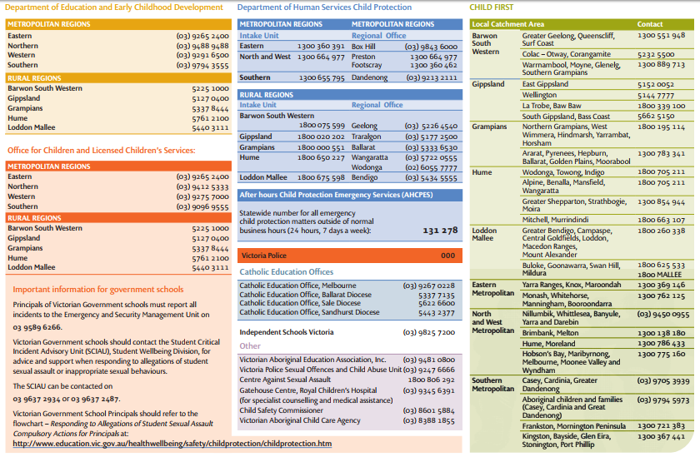
- The teacher and/or the Principal class or Welfare Officer will contact the Department of Health and Human Services by telephone as soon as possible to make an official notification on relevant phone numbers below:
- Members of the Department of Health and Human Services, or associated support or intervention services that visit the school following a notification, will interview staff and children only in the presence of a Principal class member or his/her nominee.

- All electronic copies of Mandatory reported cases are filed on the SENTRAL and can only be accessed by an administration access member

- All reports, information sheets and subsequent discussions, including phone calls are to be recorded and remain strictly confidential.

- All incidents to be monitored, and any subsequent signs or indications of abuse are also to be reported.

- While only mandated by law to report incidents of physical and sexual abuse, and neglect; teachers are also encouraged to report incidents of emotional abuse or neglect.

- Students, who disclose to staff a desire to harm themselves or others, must be reported by staff to the principal.

EVALUATION
This policy will be reviewed with the school’s review cycle or more often if necessary due to changes in regulations or circumstances.

