 | COMPLAINTS POLICY
Policy reveiwed by:  Kathie Arnold and Jamie Sharp |  | Ratified at school council:  To be reviewed:  September 2021
PURPOSE:
Aldercourt Primary school has both a desire and a responsibility to ensure that high standards of conduct are maintained by staff, students and members of the community, and that complaints are managed and resolved fairly, efficiently, promptly and in accordance with relative legislation, school and departmental policy.

AIM:
- To provide a harmonious, positive and productive school environment
- To resolve complaints fairly, efficiently, promptly and in accordance with relative legislation

IMPLEMENTATION:
It is the principal’s responsibility to provide a healthy and positive school environment that is free from discrimination and harassment. In doing so, the principal must ensure that all staff and community members are aware of their rights and responsibilities.

Staff
- All teaching staff at Aldercourt Primary School are ‘Victorian Institute Teaching’ registered and are bind this agreement along with any other Department policies and requirements. This includes the online training modules to ensure all staff are up to date with matters such as mandatory reporting, OH&S requirements and asbestos management refreshers (for certain personnel), among others
- The principal is required to use local complaints resolution procedures, where appropriate, for resolving complaints in relation to issues that fall within the school’s area of responsibility. All cases of serious misconduct – sexual offences, criminal charges, or other serious incidents – must instead be referred to the DET Employee Conduct Branch
- It is incumbent upon the principal to act where unacceptable conduct is observed or brought to his or her attention
- A complainant may at any stage choose to take their complaint directly to an external agency such as the Merit Protection Boards, Australian Education Union, Victorian Equal Opportunity Commission, Victorian Principals Federation, Victorian Principals Association, the Human Rights and Equal Opportunity Commission or the Ombudsman
- It is important that all complaints, ensuing procedures and outcomes are fully documented
- The principal may choose to respond to a complaint through an informal process in cases where the complaint is minor, the complainant wishes the matter to be dealt with informally or the complaint has arisen from lack of or unclear communication
- At any stage a staff member may be referred to the Employment Assistance Program (EAP)
- A staff member may choose to access the Employment Assistance Program (EAP)
- Formal processes will be used when informal processes haven’t been successful, a complainant seeks a formal process, or the principal believes the complaint warrants formal investigation
Full details regarding formal complaint resolution procedures are contained within the DET complaints policy http://www.vcaa.vic.edu.au/Pages/aboutus/policies/complaintspolicy.aspx

Parent/Community Complaints
- All matters must be treated with utmost confidentiality and professional respect at all times.
- the school is the first point of contact
- when contacting the school
- -Plan what you will say, so you can clearly explain what the problem is
- -Have some ideas about how the problem can be solved
- -Talk about the problem with your child’s teachers by telephone or organise a face to face meeting
- -If you still have a concern you may want to speak further regarding the issue/concern with the sub school co-ordinator, Assistant Principal or Principal
- parents/caregivers may be supported at any meeting by a friend, colleague or representative from a support organisation
- Parties dissatisfied with the process can appeal to the previously mentioned external agencies
- If the matter is still not resolved you can contact the South East Victoria Regional Office who will assist you and the school to find a solution, Furthmore, full details regarding parent formal complaint resolution procedures are contained within the DET Parent Concerns Policy chrome-extension://gbkeegbaiigmenfmjfclcdgdpimamgkj/views/app.html

Below is the Parent Complaint Flowchart

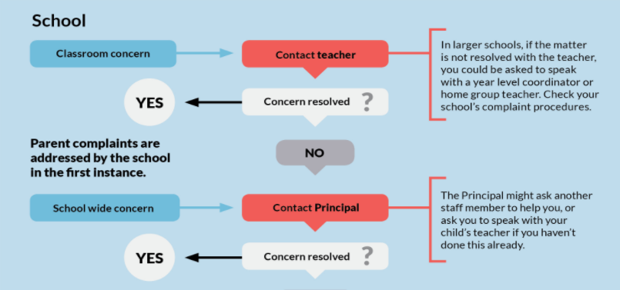
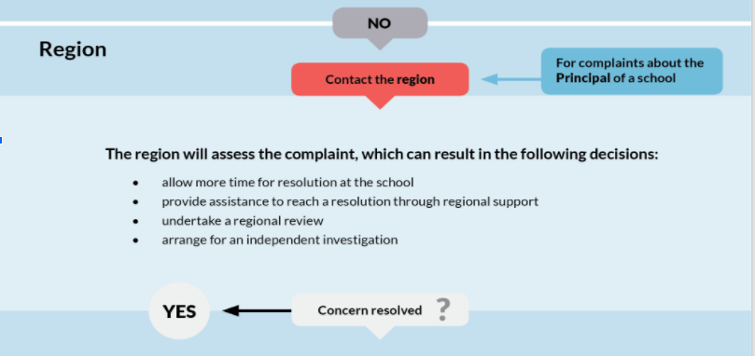
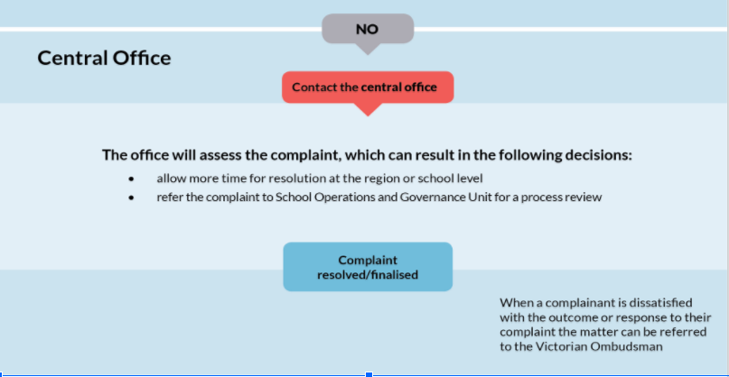
- Advice about raising a concern or making a complaint is available from Parents Victoria – 0419 716 171 (Free call from outside Melbourne: 1800 032 023 or http://www.parentsvictoria.asn.au/

EVALUATION
This policy will be reviewed with the school’s review cycle or more often if necessary due to changes in regulations or circumstances.

